**EE3211 Test Instruction**

Course code & title: EE3211 Modelling Techniques

Time allowed: 17:00 – 18:30, 22/2/2021

1. Please enter the Zoom session 15 minutes before the test start time, i.e. 16:45pm.
2. There are 15 questions in the test (three question types: multiple choice, true/false, and/or fill in the blank). All the questions shown are compulsory.
3. We adopt a two-device approach. You will be required to arrange a location, i.e. at your home, with sufficient privacy and which is quiet, and have a computer with camera and Zoom installed, plus a secondary device also with camera (on a stand). They shall be arranged as shown in the following Figure to capture a “face-to-face” angle and an approximate 105-degree view of hands and keyboard (without broadcasting their screen contents). Device 2 will video record students (capturing students’ hands) while they are taking the test.

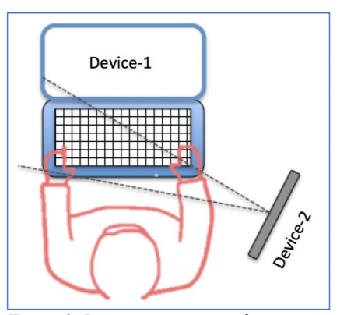

You should keep the video as additional evidence of your attempt to complete the assessment. Both devices will need to be turned on throughout the entire examination. During the test, you may be asked to pick up the second device and “sweep” your location for a complete view of the surroundings.

1. No talking with peers by any means during the test. Any cheating activities will result in zero points in the test.
2. This is a CLOSE BOOK test, candidates are allowed to use the following materials:

* Hong Kong Examination Authority Approved (HKEAA) calculator

1. Attendance will be recorded, please prepare your student ID card in case you will be asked to show it.
2. Contact:

[kkhchan@cityu.edu.hk](mailto:kkhchan@cityu.edu.hk) (Instructor), [rxhuang4-c@my.cityu.edu.hk](mailto:rxhuang4-c@my.cityu.edu.hk) (TA)